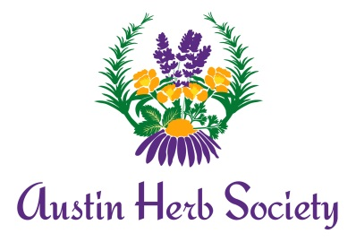
Sponsor Membership Application Form
01 June 2021 through 31 May 2022: $75.00

☐ Renewing Sponsor ☐ New Sponsor

Name of Business: Click or tap here to enter text.
Address: Click or tap here to enter text. City: Click or tap here to enter text. State: Click or tap here to enter text. Zip: Click or tap here to enter text. Phone: Click or tap here to enter text.
Website: Click or tap here to enter text.
Contact Name: Click or tap here to enter text.
Email (required): Click or tap here to enter text.
Business description or tagline to be included in the sponsor list on our website (Max 25 words):
Click or tap here to enter text.

Please check your interests. We will follow-up throughout the year.
☐ Present program at member meeting ☐ Host a field trip
☐ Members-only shopping days, coupons, etc. ☐ Free table at the December monthly meeting
☐ Discounts for AHS members

Share your ideas or feedback: Click or tap here to enter text.

NOTE: If also an active member of AHS, please complete a Membership Application Form

Questions? Contact Suzanne Cockreham, 512-971-8222, Email: slcockreham@yahoo.com
. . . . . . . . . . . . . . . . . . . . . . . . . . . . . . . . . . . . . . . . . . . . . . . . . . . . . . . . . . . . . . . . . . . . . . . . . . . . . . . . . . . . .
Complete this form electronically and Email to slcockreham@yahoo.com.
Mail a check payable to “Austin Herb Society” to:
Suzanne Cockreham
2907 Silverleaf Dr.
Austin TX 78757
. . . . . . . . . . . . . . . . . . . . . . . . . . . . . . . . . . . . . . . . . . . . . . . . . . . . . . . . . . . . . . . . . . . . . . . . . . . . . . . . . . . . .
For AHS Use: Credit ☐ Cash ☐ Check #______ Check date ____ _ Amt ______ Date Rcvd ______ To Treas. _____ Picture requested Picture Rcvd________In CC Notice to Officers/Chairs ________

